**Title:** Sea otter diet composition with respect to recolonization and demography in southern Southeast Alaska

**Background:** Sea otters, unlike most marine mammals, do not have blubber to keep them warm in the marine environment. Instead, sea otters maintain very high metabolisms; consuming up to 25% of their body weight in food per day to sustain these elevated metabolic costs (Costa and Kooyman 1982). Because of their voracious appetites, sea otters have large effects on the nearshore marine ecosystem in a relatively short time period, often referred to as a keystone predator (Estes and Palmisano 1974, Paine 1980). The islands around Southeast and Southcentral Alaska that sustain sea otter populations are mostly soft and mixed sediment habitats (Kvitek and Oliver 1992, Kvitek et al. 1993, Wolt et al. 2012, Weitzman 2013). In soft and mixed sediment locations, sea otters have clam-dominated diets (Kvitek and Oliver 1992, Kvitek et al. 1993, Wolt et al. 2012, Weitzman 2013). Although the diet is dominated by clams, over 100 invertebrate and fish species have been documented as sea otter prey in soft and mixed sediment habitats (Newsome et al. 2015).

For over 100 years while sea otters were absent from Southeast Alaska, the nearshore ecosystem lacked a keystone predator, allowing populations of commercially valuable organisms such as geoduck (*Panopea generosa*), red sea urchin (*S. franciscanus*), Dungeness crab (*Metacarcinus magister*), and sea cucumber (*Apostichopus californicus*) to flourish (Pritchett and Hoyt 2008, Larson et al. 2013, Hoyt 2015). Previous studies have shown reduced biomass of preferred prey once sea otters have recolonized (Larson et al. 2013, Hoyt 2015). The vicinity including Prince of Wales Island (POW) in southern Southeast Alaska has two original release locations and has commercial fishing zones for shellfish. Hoyt (2015) studied sea otter diets around POW for three seasons (2010-2012) focusing on sea otter impacts on commercially important species. Hoyt (2015) found that the number of species consumed by sea otters increases as time since recolonization increases, and abundance of commercially important species was reduced where sea otters were present vs. absent. An example of commercial shellfishery impact by sea otters is the red urchin fishery. Once sea otters recolonized the western side of POW, sea urchin dive fisheries were closed due to low urchin numbers in ADFG dive surveys (Pritchett and Hoyt 2008).

Sea otters can be used as a looking glass into the overall ecosystem because of their foraging habits. Sea otters sample benthic invertebrates at a high rate and with better skill than people can attain with SCUBA surveys (Riedman and Estes 1990, Oftedal et al. 2007). Wide-ranging studies of sea otter diets can aid in the management of commercially important and subsistence species in Southeast Alaska, while co-managing for a protected apex predator. Better understanding differences in prey across sea otter demographics can help with relation to newly inhabited zones dependent on the recolonization patterns of sea otters.

**Objective:** The overall goal of this study is to analyze sea otter diet composition according to age, reproductive class, season, and time since recolonization. To achieve this goal, I will investigate the energetic quality of sea otter prey in southern Southeast Alaska. Prey will be evaluated across different sea otter metrics such as age class, sex, and time since recolonization.

**Methods:**

Study site: This study was conducted on the western side of Prince of Wales Island (POW) in southern Southeast Alaska (Figure 1). Visual foraging locations were chosen along various habitat types throughout the sea otter range. Foraging sites were categorized by time since recolonization and location, then divided into eight zones along the western side of POW. Each zone had a minimum of 300 sea otter dives with known foraging success documented from different viewing locations over the duration of one summer field season (May 6 – August 13, 2018, 48 total observation days).

Sea otter foraging observations: Foraging observations, made from shore using established methods (Ralls et al. 1995), were used to assess sea otter diet composition. Questar telescopes (50X) were used to follow individual sea otters for one bout, which is a maximum of 20 dives, or until lost by the observer. A dive limit of 20 dives per otter prevents bias by varying dives collected over a greater range of sea otters in the area. Observer location was obtained with GPS and sea otter location was estimated based on distance from the observer. Prey handling time and total time spent at the surface was recorded with a stopwatch. For each surface interval, the observer recorded the prey item (to species level when possible), prey size relative to sea otter paw size, and percent of the prey item consumed (Ralls et al. 1995). A total of 3,524 forage dives were collected for 362 individual sea otters (each otter is one bout). Bouts that were greater than five dives were used in analysis, leaving 180 adults, 22 juveniles, and 67 otters of unknown age. Of these age groups, there were 91 females, 58 males, and 120 unknown sex. Bouts were also separated into recolonization time zones, where 46 bouts occurred in an area that was recolonized prior to 1988; 184 bouts from the middle recolonization zone (1988 to 2003); and 39 bouts from the most recent recolonization zone (after 2010).

Statistical analyses: Visual foraging observations were analyzed with MatLab (MathWorks) running the Sea Otter Foraging Analysis (SOFA) program developed to compute caloric values from known prey estimates and unknown prey estimations. SOFA uses a Monte Carlo-based simulation approach to account for unknown prey items and potential sample bias. Prey items listed as unknown are typically difficult to identify by the observer due to small size or fast handling time. SOFA estimates prey type by using other known observations in the dataset with similar sizes and handling times. Species-specific prey consumption rates are assigned to each foraging bout (Tinker et al. 2008). SOFA output was then transformed with a square-root transformation to adjust for right skew without changing null values. Number of null occurrences for each prey type were noted (Figure 2).

No significant differences were detected for sex, age class, time-since-recolonization, site, and season when using a Bray-Curtis dissimilarity matrix with multivariate dispersion. No dispersion allowed for a permutation based multivariate analysis. I ran 1,000 permutations in PerMANOVA (Anderson 2001) to obtain the probability of observed differences in diet composition analysis among sex, age class, and areas with varied time-since-recolonization. I then calculated a similarity percentage analysis (SIMPER, Clark 1993) to determine which prey classes contribute to the explained variance in the PerMANOVA analysis. Non-metric multidimensional (NMDS) ordinations were used to visualize differences in sea otter diet with relation to sex and time-since-recolonization.

**Results:** Sea otters were observed to consume a total of 45 prey taxa grouped into 11 prey groups, with 7 groups having prevalence in greater than 70 sea otter diets (Figure 2). When prey selection was examined irrespective of habitat type or site, the dominant prey taxa in the diet of sea otters (prey taxa making up more than 5% of diet) were clams (percent of diet: 69.20%, mass intake: 6.50 g/min), followed by crabs (percent of diet: 14.84%, mass intake: 1.39 g/min), and snails (percent of diet: 7.51%, mass intake: 0.71 g/min). Within the clam category, butter clams (*Saxidomus gigantea*) were the predominant observed species making up 32.3% of the overall diet (mass intake: 3.03 g/min) (Figure 2).

Sea otter diet varied with sex and time-since-recolonization, but did not vary across seasons or age class. Sex was identified as a significant factor (pseudo-F=4.51, p=0.003) along with time-since-recolonization (pseudo-F=10.70, p=0.001), and site (pseudo-F=1.84, p=0.005), with the interaction term between the two was not significant (pseudo-F=0.53, p=0.85). Because the interaction was not significant, it was removed from the model. Overall, this model with sex, time-since-recolonization, and site accounted for 20% of variance in the data (residual R2=0.80). SIMPER analysis of time-since-recolonization identified significant prey class differences for the newest time zone compared to mid and long-term time zones, but when the mid and long-term were compared to one another there were no significant differences in any prey classes. For short to long-term, significant prey classes include crabs (17.2% of contribution), snails (14.8%), mussels (14.5%), and urchins (14.3%) which together make up 61% of the total contribution. For short to mid-term, significant prey classes include crabs (17.8%), urchins (14.2%), mussels (14.2%), snails (13.6%), and cucumbers (12.3%) which together make up 72% of the total contribution. SIMPER analysis of sex identified no significant prey class differences. The prey classes that make up 55% of the total contribution are crabs (14.36% of contribution), mussels (13.7%), urchins (13.7%), and snails (13.6%).

**Discussion:** Sea otter diet varied by sex and time-since-recolonization around Prince of Wales Island. Sex, time zone, and sites, although significant, did not account for a majority of the variance in the sea otter diets. Sea otter diets in the coastal areas of POW mainly consisted of clams, regardless of age, sex, time-since-recolonization, and season. Besides clams, there were fine scale changes in diet between females and males. No particular species was significantly contributing, but looking at the NMDS plot (Figure 5) shows that besides a few outlier males, the majority of male points are tightly congregated away from crabs. One issue causing these outliers in the data may be the shrimp biomass values. The sea otters that ate shrimp have very high biomass intake estimates, in the 12-15g/min, whereas the average for the population is 5.84g/min. Slight differences in prey type between sexes have been seen in sea otter populations in Alaska and California (Tinker et al. 2008, Coletti et al. 2014). Male sea otters tend to dive deeper, and go after specialized species such as geoduck (Hoyt 2015), whereas females, specifically with pups, stick to shallower areas and lower risk prey.

Sea otter reintroductions around Southeast Alaska allowed for a space-for-time substitution (Pickett 1989). Sea otters, when recolonizing specialize on preferred, high-energy prey (Riedman and Estes 1990). Once these preferred prey are depleted, sea otters move on to less preferred prey, diversifying their diet. This study found that the sea otter diets vary for time zones, but the time zone with the most significant prey class differences is the newly recolonized area. Looking at the NMDS plot (Figure 4) shows the variation in time zone hull shapes. There are visual differences between all three zones, with each elliptical shape having different widths and orientations. The mid-term area has the most data points, with about twice as many points as short and long-term zones.

Future steps for this work should look at other environmental metrics that can potentially help explain more of the variation in sea otter diets around POW. It would also be useful to address the shrimp biomass issues in the database. This could make the sex differences more apparent.

**References:**

Anderson, M. J. 2001. A new method for non-parametric multivariate analysis of variance. Austral Ecology 26:32–46.

Clark, K. R. 1993. Non-parametric multivariate analyses of changes in community structure. Australian Journal of Ecology 18:117–143.

Coletti, H. A., T. A. Dean, K. A. Kloecker, and B. E. Ballachey. 2014. Nearshore Marine Vital Signs Monitoring in the Southwest Alaska Network of National Parks: 2012.

Costa, D. P., and G. L. Kooyman. 1982. Oxygen consumption, thermoregulation, and the effect of fur oiling and washing on the sea otter, *Enhydra lutris*. Canadian Journal of Zoology 60:2761–2767.

Estes, J. A., and J. F. Palmisano. 1974. Sea otters: Their role in structuring nearshore communities. Science 185:1058–1060.

Hoyt, Z. N. 2015. Resource competition, space use and forage ecology of sea otters, *Enhydra lutris*, in southern Southeast Alaska. University of Alaska, Fairbanks, Alaska, USA.

Kvitek, R. G., C. E. Bowlby, and M. Staedler. 1993. Diet and foraging behavior of sea otters in Southeast Alaska. Marine Mammal Science 9:168–181.

Kvitek, R. G., and J. S. Oliver. 1992. Influence of sea otters on soft-bottom prey communities in Southeast Alaska. Marine Ecology Progress Series 82:103–113.

Larson, S. D., Z. N. Hoyt, G. L. Eckert, and V. A. Gill. 2013. Impacts of sea otter (*Enhydra lutris*) predation on commercially important sea cucumbers (*Parastichopus californicus*) in Southeast Alaska. Canadian Journal of Fisheries and Aquatic Sciences 70:1498–1507.

Newsome, S. D., M. T. Tinker, V. A. Gill, Z. N. Hoyt, A. Doroff, L. Nichol, and J. L. Bodkin. 2015. The interaction of intraspecific competition and habitat on individual diet specialization: a near range-wide examination of sea otters. Oecologia 178:45–59.

Oftedal, O. T., K. Ralls, M. T. Tinker, and A. Green. 2007. Nutritional constraints on the southern sea otter in the Monterey Bay National Marine Sanctuary. Page Joint Final Report to Monterey Bay National Marine Sanctuary (and Monterey Bay Sanctuary Foundation) and the Marine Mammal Commission.

Paine, R. T. 1980. Food webs: Linkage, interaction strength and community infrastructure. The Journal of Animal Ecology 49:666.

Pickett, S. T. A. 1989. Space-for-time substitution as an alternative to long-term studies. Pages 110–135 *in* *Long Term Studies in Ecology*, G. E. Likens, editor. Springer, New York, NY.

Pritchett, M., and Z. N. Hoyt. 2008. Report to the Board of Fisheries, miscellaneous dive fisheries.

Ralls, K., B. B. Hatfield, and D. B. Siniff. 1995. Foraging patterns of California sea otters as indicated by telemetry. Canadian Journal of Zoology 73:523–531.

Riedman, M., and J. A. Estes. 1990. The sea otter (*Enhydra lutris*): behavior, ecology, and natural history. US Fish and Wildlife Service Biological Report 90:1–126.

Tinker, M. T., G. B. Bentall, and J. A. Estes. 2008. Food limitation leads to behavioral diversification and dietary specialization in sea otters. Proceedings of the National Academy of Sciences of the United States of America 105:560–565.

Weitzman, B. P. 2013. Effects of sea otter colonization on soft-sediment intertidal prey assemblages in Glacier Bay, Alaska. University of California, Santa Cruz.

Wolt, R. C., F. P. Gelwick, F. Weltz, and R. W. Davis. 2012. Foraging behavior and prey of sea otters in a soft- and mixed-sediment benthos in Alaska. Mammalian Biology 77:271–280.

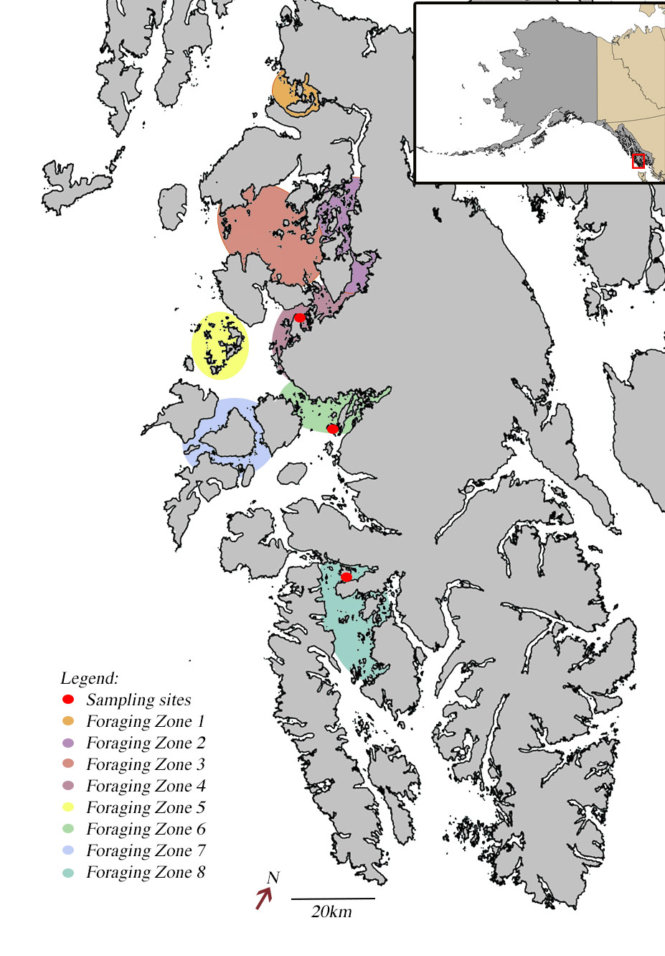

Figure 1: Map of Prince of Wales Island, Southeast Alaska. Colored polygons indicate foraging data collection zones, which coordinate with Alaska Department of Fish and Game sea otter surveys and the year sea otters were first seen. Red circles indicate invertebrate sampling sites (not a part of this project directly).

Figure 2: Distribution of sea otter prey in grams per minute in the diet by biomass transformed with fourth-root transformation and all null values removed. Each pray class is separated, and null g/min occurrences are listed in red. All prey classes with greater than 180 null values were removed from final analysis.

103 5 104 77

178 109 199 220

236 160 241



Figure 3: Overall sea otter diet composition for all dives collected in 2018 by prey class (x-axis). Diet is proportion of the diet by biomass. Error bars show one standard deviation from estimated biomass percentage.



Figure 4: Plot of the first two axes of a non-metric multidimensional (NMDS) ordination of prey classes (text) and sea otters (points) separated out by time-since-recolonization. The longest recolonization time zone are gray circles, middle recolonization time zone are orange triangles, and least amount of time-since recolonization are blue squares. Filled hulls were made to cover all area covered by each time zone. Hulls were not significantly different in dispersion (anova, p= 0.36).



Figure 5: Plot of the first two axes of a non-metric multidimensional (NMDS) ordination of prey classes (text) and sea otters (points) separated out by sex. Males are blue triangles and females are red circles. Filled hulls were made to cover all area covered by each time zone. Hulls were not significantly different in dispersion (anova, p= 0.91).